**Sportz Digital Watch**

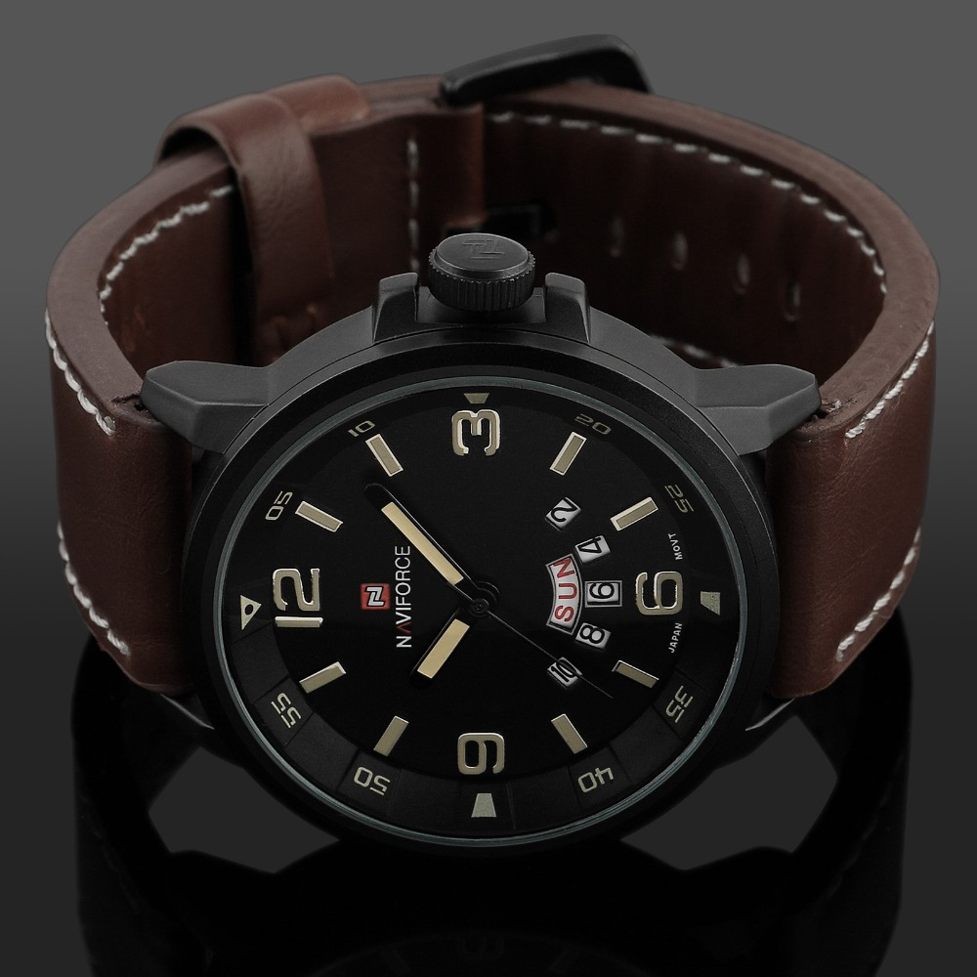

Price:

Rs:5,500